Press Release
For Immediate Release
Jockey® South Africa’s “Take One For The Team" Campaign: A Tribute to Rugby Excellence
As rugby fever starts to sweep across the globe with the start of this year’s world cup around the corner, iconic international underwear brand – Jockey® – is embracing the fever surrounding the championships with its tongue-in-cheek campaign headlined, “Take one for the Team”. The campaign is a tribute to the national team and echoes the national team’s hopes of capturing a fourth title, while also providing supporters of some other countries the opportunity to support their teams too.
Bruce McMurray, General Manager of Jockey® South Africa, explains, “Our campaign speaks to our nation's historic feats, which resonate both locally and on a global stage. As proud South Africans, we stand shoulder to shoulder with our team and aim to celebrate their legacy with our new limited-edition and specially curated world cup product range. While we fly the flag high for our national team as the look to defend their championship title we also celebrate the melting pot that is South Africa, which is rich in history and global heritage. We’ve created a campaign inclusive of world rugby to capture the essence and camaraderie of the sport but with a distinctly South African flavour.”
The campaign's vibrant visuals transport you to the stadium, immersing you in the fan experience. The “cheeky” signature image used on billboards showcases a row of men interlinked in a team line-up pose and facing away from the camera wearing only colourful team-inspired Jockey® trunks.
The term, “Take one for the Team”, is a play on words encouraging consumers to purchase a pair of trunks or bra tops in the colours of their favourite team. To sweeten the deal and encourage Jockey® garment purchases, they've introduced an exciting competition. Simply buy any Jockey® garment before September 30th, 2023, and you'll have the chance to win a fantastic festive world cup screening experience valued at R50,000 for you and 20 friends.
Jockey’s limited-edition team-inspired garments that includes not only men’s trunks but ladies’ bra tops, lets fans support their teams on and off the field by taking one for the team by buying and wearing their team’s colours. The Jockey® Colour Blocked Cotton Stretch Peak Performance short trunk offers style and comfort, featuring contoured panels and a 2-needle cover seam detail, striped out gusset, and wide jacquard elastic. The Jockey® Festive bra, wire-free with adjustable straps and removable pads, offers lasting quality with sustainable 95% cotton and 5% lycra. The trunk boasts a striped out gusset for supreme comfort and chafe reduction, while the bra tops combine everyday comfort with luxurious softness, encapsulating the essence of simplicity and elegance. All the garments in the range are crafted responsibly in partnership with the Better Cotton Initiative (BCI).
“Although we are a global brand, we are proudly South African too! The memory of Nelson Mandela uniting the nation in 1995 when the rugby team secured their inaugural world cup victory, stands as a significant milestone and a testament to the impact that sport plays in our lives as a proud sporting nation. Our passion for sport is in our blood, woven into our identity, and supporting our national team is second nature. On behalf of Jockey® South Africa, we extend our best wishes and luck to our national heroes as they prepare to take the field in the hopes of keeping the cup on South African soil," remarks McMurray.
No matter which side you’re on, take one for your team with Jockey®. Purchase your garment in-store or online at www.jockey.co.za
ENDS

Words: 392
Images: Campaign images
Distributed on behalf of: Jockey® South Africa
Date: August 2023

Notes to the editor:
About – 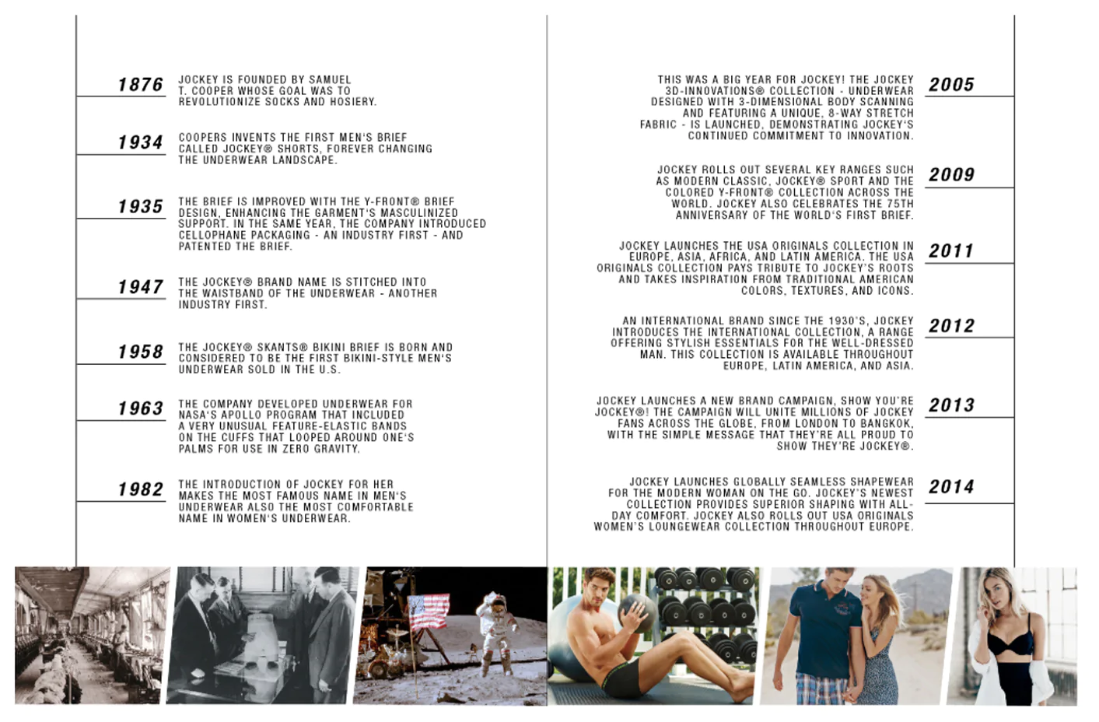

For more information or visuals, please contact Janna Strang on janna@rainmakermarketing.co.za / 082 551 3865 or email Mbali Mpofu on mbali@rainmakermarketing.co.za

